Year 2 Homework
In addition to regular reading, practising number bonds on Numbots, additional phonics practise on Active Learn and spellings on Spelling Shed, this term we are giving the children a chance to choose their weekly homework task. Each week the children will choose one of the tasks set for that week. All homework will be completed in the children’s homework books and are to be handed in on the date shown.
This is loaded onto the school website where there are the extra resources for some of the tasks (choice 3 for the maths and the reading activities).
 | Choice 1 | Choice 2 | Choice 3
Maths  Due in: Monday 14th November  Learning intention:  To recall all number bonds to and within 10 and use these to reason with and calculate bonds to and within 20. | 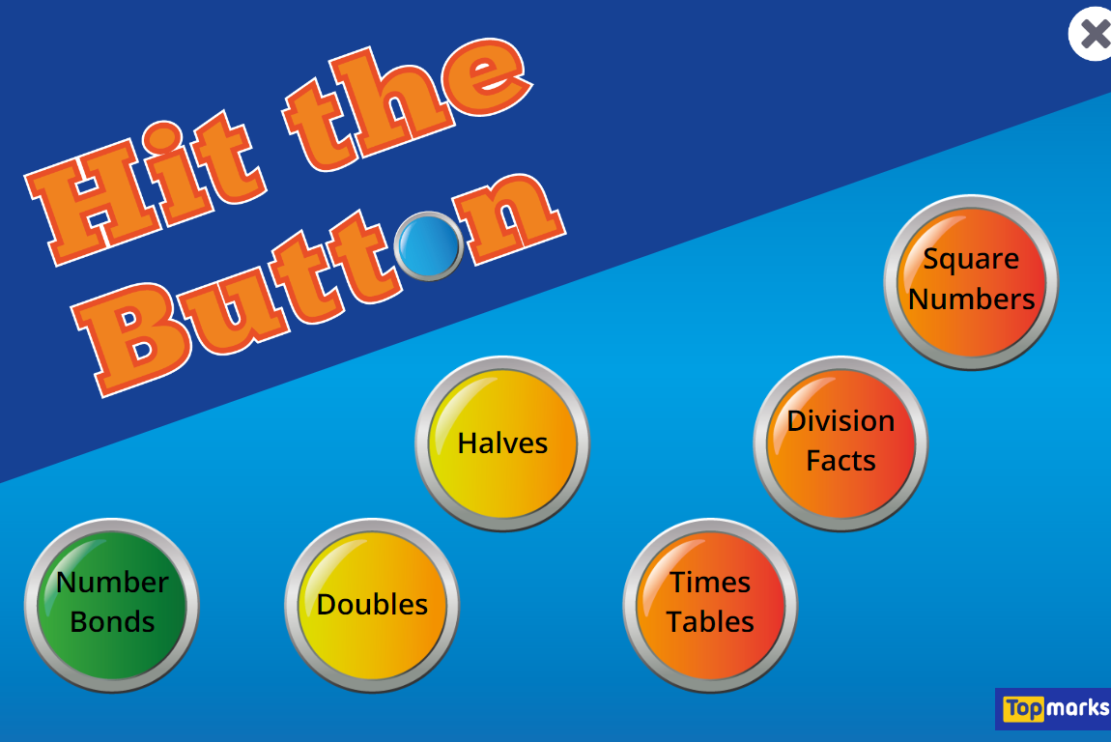  Click on the link below and practise your number bonds to 10 and 20.  https://www.topmarks.co.uk/maths-games/hit-the-button | Complete the activity on Nrich with the link below.  https://nrich.maths.org/1257   | Complete the maths problems, which can be found on the website.  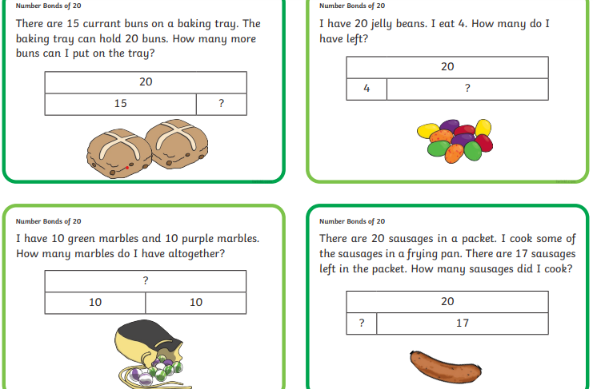
English  Due in: Monday 21st November  Learning intention:  To spell many common exception words. | Choose 5 of the words from the common exception word list in your homework book (ones not highlighted).  Cut out each letter from magazines or newspapers as shown below.  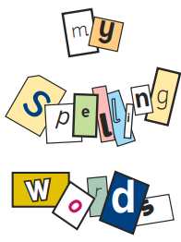 | Choose 10 of the words from the common exception list in your homework book (ones not highlighted).  Write them out in a pyramid as shown below.  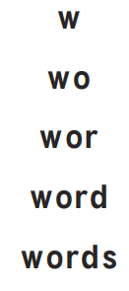 | Choose 10 of the words from the common exception list in your homework book (ones not highlighted).  Practise them in any way you choose.  Then write them in a sentence (one sentence for each word).
Reading  Due in: Monday 28th November  Learning intention:  To answer questions and make some inferences based on a text. | Complete ‘Zoom to the Moon’ (which can be found on the website).  Write the answers in your book. | Complete ‘The Queen’s Elephant’ (which can be found on the website).  Write the answers in your book. | Complete ‘All About Ocean Plastics’ (which can be found on the website).  Write the answers in your book.
Geography  Due in: Monday 5th December  Learning intention:  To locate countries from around the world. | Choose a country and research its flag. Draw it in your book. | Choose a country and research its flag and some animals which can be found there. Draw these in your book. | Research a country you have been to, or would like to go to, and create a fact file.
Festivals  Due in: Monday 12th December  Learning intention:  To retrieve information. | Research a winter festival from another country and draw the key features of it. | Research different Christmas traditions from around the world and draw a comparison of 2 of them. | Research different Christmas traditions from around the world and write a comparison of 2 of them.

Maths Activity – Choice 3
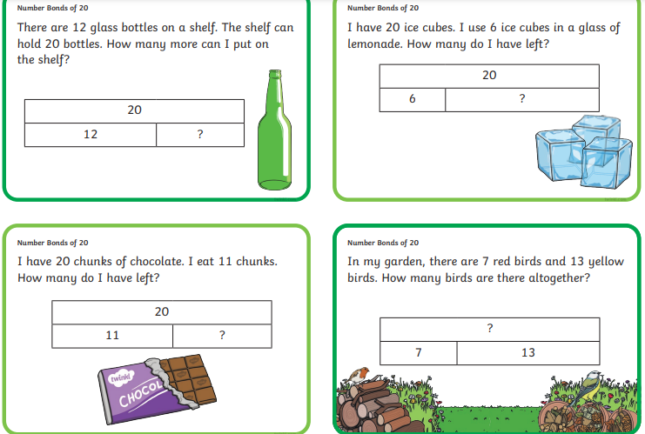

Reading Choices 1, 2 and 3
Choice 1
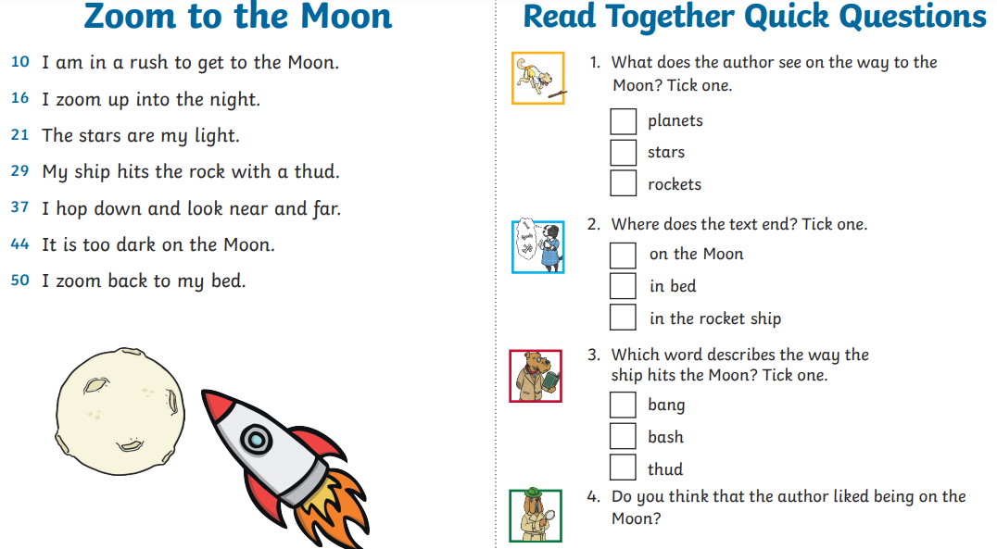

Choice 2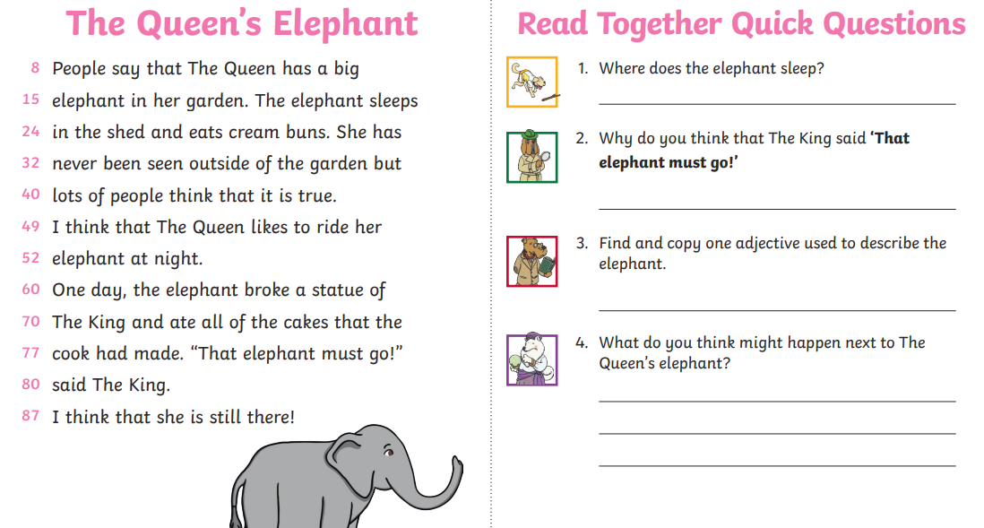

Choice 3


