


Dear Parents and Carers,

As you know we follow the Bug Club Phonics scheme within school. We have put a sticker on your child’s reading diary with their log in details so that they can access Bug Club online at home. Each week, new letter sounds and games will be added which the children have also used within class during their phonics sessions. Please find details of how to access Bug Club below.

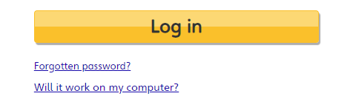
Firstly, go to www.activelearnprimary.co.uk
Click on the yellow Log in button and use your child's username, password and school code that the teacher provided.

Once logged in you will be taken to the Pupil World homepage. This is where you can access all of the homework.
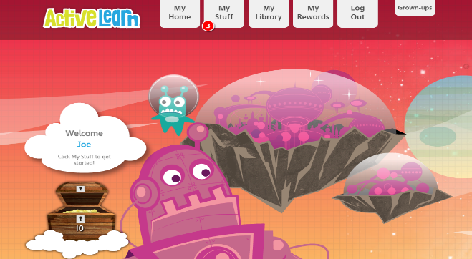
You will see there are several tabs at the top of the page: My Home, My Stuff, My Library, My Rewards, Log Out and Grown-Ups.
Use My Home to change the home page theme.
My Stuff is where any new homework gets sent to. The number displayed indicates how many pieces of homework have been allocated to your child.

How to find games that have been allocated
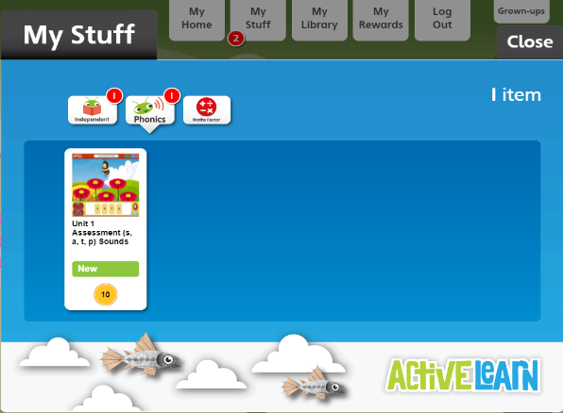

The games can be found in the Phonics tab.
The gold coin represents how many coins the child will get as a reward for completing the game.

Playing the games
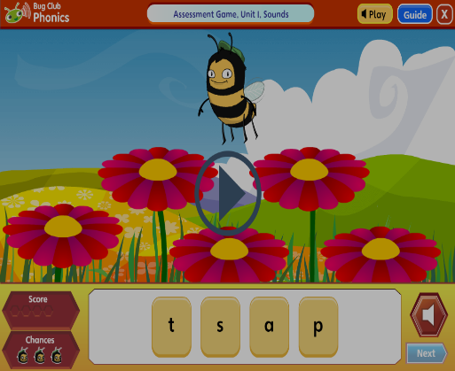
Whenever you open a game the first step is to click the play button and the narrator will provide the instructions for the game. You can also click the Guide button at the top right of the screen for written instructions.

In every game your child will have 3 chances to answer each question. If they get all three wrong, the narrator will provide the correct answer.

You can see how you did in the score counter. A green hexagon is shown for each question answered correctly and a red hexagon is shown for each answered incorrectly.

Rewards for finishing a game
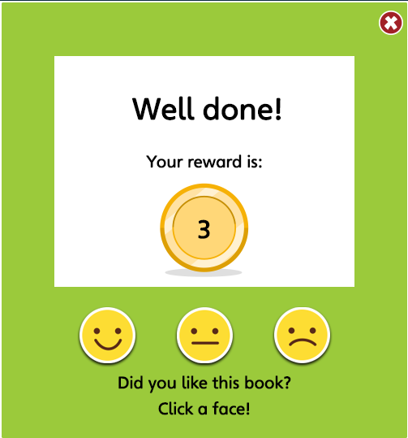
Your child will be given a reward after attempting every activity and clicking finish at the end of the game.

Grown-ups area

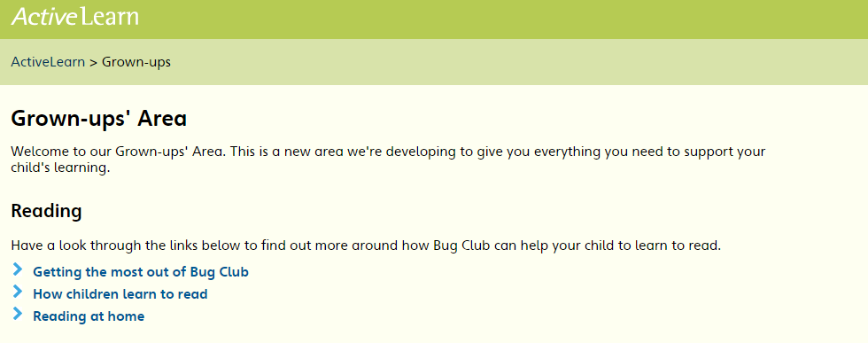
In this area there are some top tips on how you can help your child read from home.
Need help?
You can also use the Help guide link to go over any functionality or technical support questions.
Please note: Bug Club strongly recommend using Google Chrome or Mozilla Firefox web browsers with ActiveLearn. If you prefer to use Internet Explorer, please check you have at least IE9 in order for everything to work as it should.

Many thanks,
Reception Team

