English | Maths | Theme
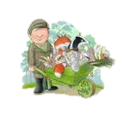  Write a story about the Wright brothers.  Use the skills we have learnt in English. | Go on a 2D shape hunt at home.  How many circle/squares/triangles can you find? | Design a healthy meal.  Remember the food groups: carbohydrates, protein, dairy and fruit/vegetables.
Research facts about airports. Turn it into a fact poster or fact page. | Practise telling the time to o’clock and half past.  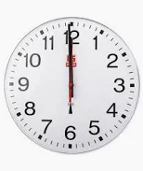 | Take part in 30 mins physical activity to raise your heartbeat.
  Find a poem you really like.  Copy it out in your neatest handwriting and practise reading it out loud. | Find some coins in your house.    How much money is there? Practise adding up different coins. | 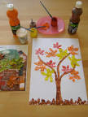  Create a piece of artwork inspired by the weather.
  Make a list of 3 of your favourite books.  Why do you enjoy them? | Practise counting up in 2 ,3, 5 10.  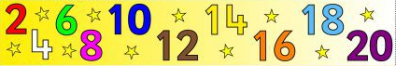 | 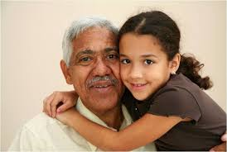  Talk to a different elderly relative about their childhood.
Year 2 Autumn Term - Homework Bingo.
Please try to complete six homework tasks: 2 from English, 2 from Maths and 2 from theme.
Homework to be brought in WC Monday 30th October to share with the class.

