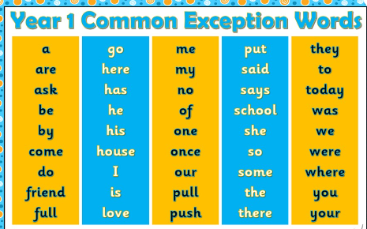
Please learn to read and spell the first two columns of words.

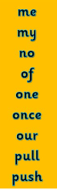
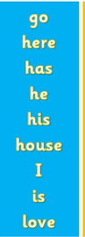
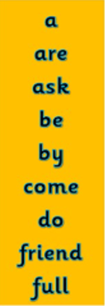

There is no one way to learn to spell words. Below are some strategies that you can use.
Fun ways to learn spellings at home


