
Year 1 homework
Spring Term 1
We are giving the children in Year 1 the opportunity to choose their own homework. They will need to complete 1 writing, 1 maths and 2 theme activities. These can be presented as creatively as possible through writing, drawings, pictures, displays, models, or anything else creative that your child thinks of. If you have any questions regarding your child’s homework, please speak to your child’s class teacher. We recommend that you help your child to spread the homework out over the half term ready to be brought into school on Thursday 9th February 2023. The children will then be given the opportunity to share their homework with their peers.
Reading | Writing | Maths | Theme
Please read with your child as much as possible. Try to read different genres including fiction, non-fiction, poetry, scripts, and comics.    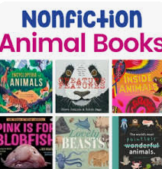  This half term we are learning about animals in science and exploring the different continents in geography.    Have you ever explored a nonfiction book about the continent of Europe? | Can you write a fact page about your favourite country in Europe?    With an adult’s permission use the website below to help you.  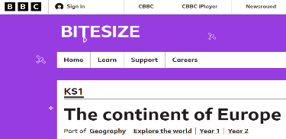 | 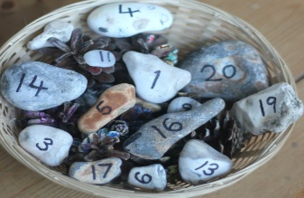  Make your own number pebbles to practise addition and subtraction within 20.  Remember to make the +, - and = symbols.  Take a photograph of your learning. | Use an old shoe box to create a model of the habitat, that your amazing animal would live in.  Remember to include where it would sleep, hide, and what it would need for food and water.  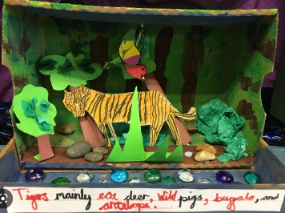
 | Write a poem about the five senses.  I like the smell of…  I like the touch of…  I like the sight of…  I like the sound of…  I like the taste of…  Try to use exciting adjectives. | Use playing cards to match the pairs of numbers that make 20.  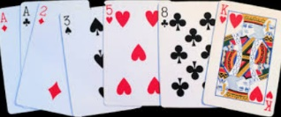  Picture cards are worth 10.  An ace can be 1 or 11.  Take turns in a game to turn over two cards. Find a pair that makes 20.  Record your answers. | Can someone in your family teach you to sew? It could be just a simple running stitch.  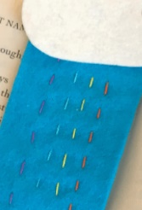  Sew a running stitch pattern to make a book mark. Try something more challenging like sewing a puppet.
 | 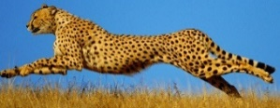  Make a poster about an animal that has amazing senses or skills.  Use a nonfiction book to read and research about the animal first.  Your poster can have pictures, labels, and statement sentences.  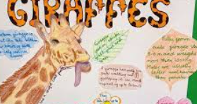 | 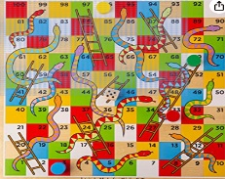  Play any games that involve counting with numbers.  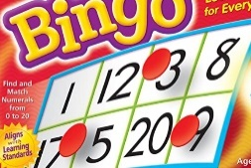  Why not even make your own? This will allow you to practise writing numbers accurately. | Remember to have wellbeing time during a busy half term. This is something your whole family can do.  Take photos or draw about your favourite activity.  - Jump in the leaves.  - Watch the clouds.  - Have a movie night.  - Drink hot chocolate.  - With an adult’s permission, google a ‘Cosmic Yoga’ story activity to move to.    

