Nursery Long Term Plan 2026-27
 | Autumn 1 (7.5 weeks) | Autumn 2 (7 weeks) | Spring 1 (6 weeks) | Spring 2 (5 weeks) | Summer 1 (7 weeks) | Summer 2 (6 weeks)
Literacy (links to English)  Development matter- 3 & 4 years olds will learning to:  Understanding the five key concepts about print:  -print has meaning  -print can have different purposes  -we read English text from left to right and top to bottom  -the names of the different parts of a book page sequencing  Develop their phonological awareness, so that they can:  -spot and suggest rhymes  -count or clap syllables in a word  -recognise words with the same initial sound, such as money and mother  Engage in extended conversations about stories, learning new vocabulary  Use some of their print and letter knowledge in their early writing. For example, writing a pretend shopping list that starts at the top of the page; writing m for mummy  Write some or all of their name  Write some letters accurately | CUSP focus books:  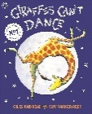  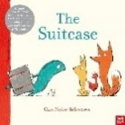  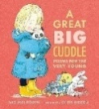  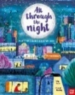  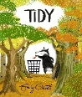  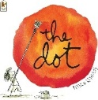  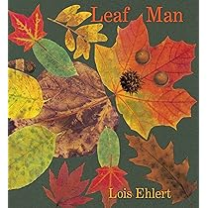  Additional texts:  My favourite books  Penpals for handwriting:  Developing gross motor skills (units 1-3)  Bugclub phonics: Unit A  Letters of the week:  s,a,t,p,i,n,m  Story scribing | CUSP focus books:  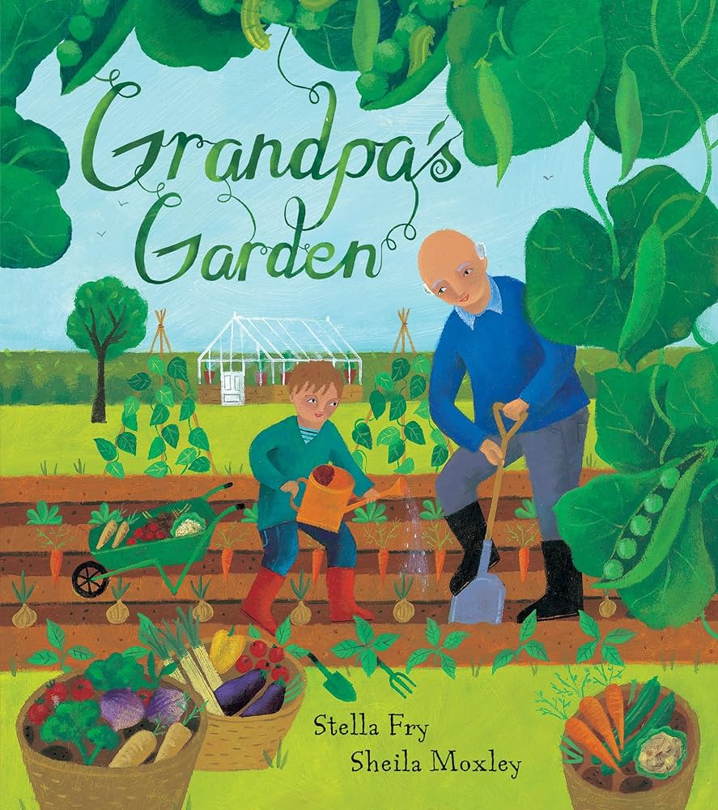  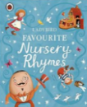  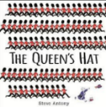  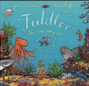  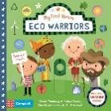  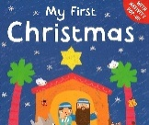  Additional texts:  Christmas stories- nativity & classic stories, nursery rhymes  Penpals for handwriting:  Developing gross motor skills (unit 4). Developing fine motor skills (units 5&6)  Bugclub phonics: Unit B  Letters of the week:  d,g,o,c,k, e, u  Story scribing | CUSP focus books:  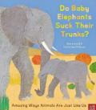  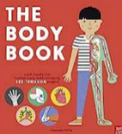  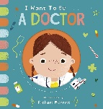  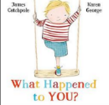  Additional texts:  Winter non-fiction texts  Penpals for handwriting:  Developing fine motor skills (units 7-9)  Bugclub phonics: Unit C  Letters of the week:  r,h,b,f, l, j  Story scribing | CUSP focus books:  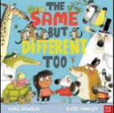  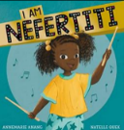  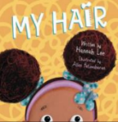  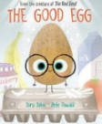  Additional texts:  Easter stories  Penpals for handwriting:  Developing fine motor skills (unit 10). Developing patterns (units 11 & 12)  Bugclub phonics: Unit D  Letters of the  week:  v,w,x, y, z  Story scribing | CUSP focus books:  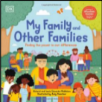  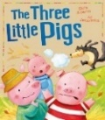  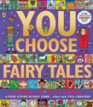  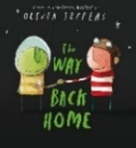  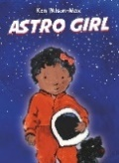  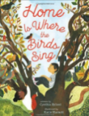  Additional texts:  Fairy tales  Penpals for handwriting:  Developing patterns (units 13 &14)  Bugclub phonics: Unit E  Letters of the week:  s,a,t,p,i,n, m  Story scribing | CUSP focus books:  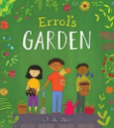  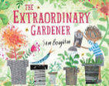  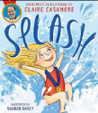  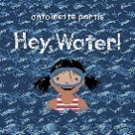  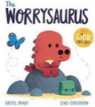  Additional texts:  Starting school books  Penpals for handwriting:  Developing patterns (units 15-17)  Bugclub phonics: Unit F  Letters of the week:  d,g,o,c,k, e  Story scribing
Maths  Development matter- 3 & 4 years olds will learning to:  • Develop fast recognition of up to 3 objects, without having to count them individually (‘subitising’).  • Recite numbers past 5.  • Say one number for each item in order: 1,2,3,4,5.  • Know that the last number reached when counting a small set of objects tells you how many there are in total (‘cardinal principle’).  • Show ‘finger numbers’ up to 5.  • Link numerals and amounts: for example, showing the right number of objects to match the numeral, up to 5.  • Experiment with their own symbols and marks as well as numerals.  • Solve real world mathematical problems with numbers up to 5.  • Compare quantities using language: ‘more than’, ‘fewer than’.  • Talk about and explore 2D and 3D shapes (for example, circles, rectangles, triangles and cuboids) using informal and mathematical language: ‘sides’, ‘corners’; ‘straight’, ‘flat’, ‘round’.  • Understand position through words alone – for example, “The bag is under the table,” – with no pointing.  • Describe a familiar route.  • Discuss routes and locations, using words like ‘in front of’ and ‘behind’.  • Make comparisons between objects relating to size, length, weight and capacity.  • Select shapes appropriately: flat surfaces for building, a triangular prism for a roof etc.  • Combine shapes to make new ones – an arch, a bigger triangle etc.  • Talk about and identifies the patterns around them. For example: stripes on clothes, designs on rugs and wallpaper. Use informal language like ‘pointy’, ‘spotty’, ‘blobs’ etc.  • Extend and create ABAB patterns – stick, leaf, stick, leaf.  • Notice and correct an error in a repeating pattern.  • Begin to describe a sequence of events, real or fictional, using words such as ‘first’, ‘then...’ | Number songs. Counting up and backwards from 5.  Say one number for each item in order: 1,2,3,4,5.  Show ‘finger numbers’ up to 5.  Know when the last number reached when counting a small set of objects tells you how many there are in total.  CUSP book links:  Sequencing pictures (Tiddler)  Counting in nursery rhymes (Favourite nursery rhymes) |  | Develop fast recognition of up to 3 objects, without having to count them individually (‘subitising’).  Recite numbers past 5.  Link numerals and amounts: for example, showing the right number of objects to match the numeral, up to 5.  Experiment with their own symbols and marks as well as numerals.  Introduce ‘Numberblocks’ 1-5.  CUSP book links:  Sorting the baby animals. Can you count the whales in the water tray (to 5)? (Do baby animals suck their trunks?)  Begin to use comparative language (The same but different too)  Sorting from biggest to smallest. Drawing simple shapes. (The good egg) |  | Compare quantities using language “more than” and “fewer than”.  Talk about and explore 2D and 3D shapes (for example, circles, rectangles, triangles and cuboids) using informal and mathematical language: “sides”, “corners”, “straight”.  Continue with Numberblocks 1-5 and start to focus on one and one is two.  CUSP book links:  Learning some 2D and 3D shapes (The three little pigs)  Using position to describe where something is (The three little pigs)  Following a recipe. Measuring out ingredients (Astro girl)  Shapes and patterns (The Worrysaurus)
PSED  Development matter- 3 & 4 years olds will learning to:  • Select and use activities and resources, with help when needed. This helps them to achieve a goal they have chosen, or one which is suggested to them.  • Develop their sense of responsibility and membership of a community.  • Become more outgoing with unfamiliar people, in the safe context of their setting.  • Show more confidence in new social situations.  • Play with one or more other children, extending and elaborating play ideas.  • Find solutions to conflicts and rivalries. For example, accepting that not everyone can be Spider-Man in the game, and suggesting other ideas.  • Increasingly follow rules, understanding why they are important.  • Remember rules without needing an adult to remind them.  • Develop appropriate ways of being assertive.  • Talk with others to solve conflicts.  • Talk about their feelings using words like ‘happy’, ‘sad’, ‘angry’ or ‘worried’.  • Understand gradually how others might be feeling.  • Be increasingly independent in meeting their own care needs, e.g. brushing teeth, using the toilet, washing and drying their hands thoroughly.  • Make healthy choices about food, drink, activity and toothbrushing. | School rules.  Develop nursery routines.  Developing relationships with adults and children.  Wellbeing week: Giraffes can’t dance- relating to character emotions  Choosing own lunch and snack options.  Jigsaw PSHE:  Being me in my world  CUSP book links:  Learning to empathise with characters from a story (The suitcase) | Understanding own feelings and talking about them.  Anti-bullying week - Kindness  Jigsaw PSHE:  Celebrating difference | Oral health- tooth brushing.  Develop confidence to try new activities.  Jigsaw PSHE:  Dreams & goals  CUSP book links:  Look at your baby teeth in a mirror. Are they wobbly yet? (Do baby animals suck their trunks?)  Learning how to clean teeth properly (The body book) | Understanding feelings of others.  Jigsaw PSHE:  Healthy me  CUSP book links:  Talk about how a character might feel and why (I am Nefertiti)  Learning that sometimes different hairstyles are linked to religion or culture (My hair)  Understand the importance of helping others. Understanding different emotions. (The good egg) | Turn taking and solving conflicts.  Jigsaw PSHE:  Relationships  CUSP book links:  Understand how being helpful can lead to new friendships (The way back home)  Name some healthy foods found in packets (Astro girl)  How does being at home make you feel? (Home is where the birds sing)  Learn about emotions related to losing something (My family and other families) | Transitions and new beginnings  Visits to new classrooms and playtimes in Reception playground.  Jigsaw PSHE:  Changing me  CUSP book links:  Growing fruits and vegetables (Errol’s garden)  Fears/dislikes and following your dreams. Learning about Paralympians (Splash!)  Understanding what a worry is and how they make us feel. Learn some strategies to try if we are worried (The Worrysaurus)  Being sustainable-turning off taps when not in use (Hey, water!)
Communication and language  Development matter- 3 & 4 years olds will learning to:  • Enjoy listening to longer stories and can remember much of what happens.  • Pay attention to more than one thing at a time, which can be difficult.  • Use a wider range of vocabulary.  • Understand a question or instruction that has two parts, such as “Get your coat and wait at the door”.  • Understand ‘why’ questions, like: “Why do you think the caterpillar got so fat?”  • Sing a large repertoire of songs.  • Know many rhymes, be able to talk about familiar books, and be able to tell a long story.  • Develop their communication, but may continue to have problems with irregular tenses and plurals, such as ‘runned’ for ‘ran’, ‘swimmed’ for ‘swam’.  • Develop their pronunciation but may have problems saying: - some sounds: r, j, th, ch, and sh - multisyllabic words such as ‘pterodactyl’, ‘planetarium’ or ‘hippopotamus’  • Use longer sentences of four to six words.  • Be able to express a point of view and to debate when they disagree with an adult or a friend, using words as well as actions.  • Start a conversation with an adult or a friend and continue it for many turns.  • Use talk to organise themselves and their play: “Let’s go on a bus... you sit there... I’ll be the driver. | CUSP book links:  Learn to explain some of the vocabulary in a poem, perform simple poems and make comments about poems. (A great big cuddle)  Listening to stories and giving opinions. | CUSP book links:  Talk about their personal experiences (The Queen’s Hat)  Learning all or most of the words and actions of nursery rhymes (Favourite nursery rhymes)  Perform to an audience (nativity). | CUSP book links:  Learning how to ask polite questions.  Engage in extended conversations about stories.  (What happened to you?) | CUSP book links:  Explain how the main character feels in the story (I am Nefertiti) | CUSP book links:  Understanding ‘why’ questions (The way back home)  Discuss favourite fairy tales and key language (You choose fairy tales)  Talking about things that are important to us (My family and other families) | CUSP book links:  Learn to share their opinions and ideas (Splash!)
Physical development (links to PE)  Development matter- 3 & 4 years olds will learning to:  • Continue to develop their movement, balancing, riding (scooters, trikes and bikes) and ball skills.  • Go up steps and stairs, or climb up apparatus, using alternate feet.  • Skip, hop, stand on one leg and hold a pose for a game like musical statues.  • Use large-muscle movements to wave flags and streamers, paint and make marks.  • Start taking part in some group activities which they make up for themselves, or in teams.  • Increasingly be able to use and remember sequences and patterns of movements which are related to music and rhythm.  • Match their developing physical skills to tasks and activities in the setting. For example, they decide whether to crawl, walk or run across a plank, depending on its length and width.  • Choose the right resources to carry out their own plan. For example, choosing a spade to enlarge a small hole they dug with a trowel.  • Collaborate with others to manage large items, such as moving a long plank safely, carrying large hollow blocks.  • Use one-handed tools and equipment, for example, making snips in paper with scissors.  • Use a comfortable grip with good control when holding pens and pencils.  • Show a preference for a dominant hand.  • Be increasingly independent as they get dressed and undressed, for example, putting coats on and doing up zips | Learning how to dress and undress independently  Putting on our own wetsuits and wellies  Moving around spaces in different ways.  Understanding how different parts of our bodies move.  Working with others to play simple games.  Throw and catch a large ball.  Riding tricycles.  Using the large play equipment.  Dancing to music  Moving with scarves | Learning how to dress and undress independently  Climbing  Balancing bean bags on body parts  Perform Christmas songs with actions  Digging in the forest area  Cutting grass using small scissors  Doing up zips on coats | Learning how to dress and undress independently  CUSP book links:  Cutting out their own masks (Do baby elephants suck their trunks?)  Pirates-balancing along planks (What happened to you?) | Learning how to dress and undress independently  CUSP book links:  Fast and slow (The same but different too) | Learning how to dress and undress independently  Team games  Throwing to a target  Obstacle races | Learning how to dress and undress independently. Team games.  Sports day.  Dance.  CUSP book links:  Using tweezers to sort seeds (Errol’s garden)  Making obstacle courses to cross a ‘river’ (Hey, water!)
UW (links to history)  Begin to make sense of their own life-story and family’s history. | Know who is in our immediate families/who we live with. | CUSP book links:  History of nursery rhymes (Favourite nursery rhymes)  Learn about key figures who are/were (Eco warriors)  Learning who the royal family are. (The Queen’s Hat)  Learn about some important people in history (Eco Warriors) | CUSP book links:  Learn about how babies grow and develop. Look at photos of ourselves as babies and how we have changed (Do baby elephants suck their trunks?) | CUSP book links: | CUSP book links:  Who is in your family? (My family and other families)  History of buildings and housing types (The three little pigs) | CUSP book links:  Castles (Splash!)
UW (links to geography)  Talk about what they see, using a wide range of vocabulary.  Show interest in different occupations. | CUSP book links:  When do people use a suitcase? How do we travel? (The Suitcase)  Learning about people leaving their homes or country (The Suitcase)  Know that people do lots of different jobs (All through the night)  Name some of the things you find in cities (All through the night)  What is a street? (A great big cuddle)  Exploring our grounds & forest area | CUSP book links:  What does the ocean look like? What lives in the ocean? (Tiddler)  Learn that London is the capital of England. Name some London landmarks. Learn about different weather types. (The Queen’s Hat)  Understanding climate and what climate change means.  Learning about ways of travelling long distance.  Habitats. (Eco Warriors)  Use vocabulary linked to our local area and places that are special to us.  Learning about doctors surgeries (Favourite nursery rhymes)  Why is it important to look after our planet? How can we protect habitats? What items do you recycle at home? (Eco Warriors) | CUSP book links:  Where have you seen a doctor before? What might doctors uses? (I want to be a…doctor) | CUSP book links:  Learning about hairdressers and barbers (My hair) | CUSP book links:  What different types of aeroplanes are there? (The way back home)  Understand what an astronaut is (Astro girl)  What types of homes are there? (Home is where the birds sing)  Learning about different houses (The three little pigs) | CUSP book links:  Learning about growing fruit and vegetables. Learn that different fruit and vegetables are grown in different countries & climates. (Errol’s garden)  Drawing a simple map (You choose fairy tales) & (The Worrysaurus)  What is a flat/apartment? What is a skyscraper? (The extraordinary gardener)  Where does water come from? How is it used? (Hey, water!)
UW (links to science)  Use all their senses in hands-on exploration of natural materials.  Explore collections of materials with similar and/or different properties.  Talk about what they see, using a wide range of vocabulary.  Plant seeds and care for growing plants.  Understand the key features of a life cycle of a plant and an animal.  Begin to understand the need to respect and care for the natural environment and all living things.  Explore and talk about different forces they can feel.  Talk about the differences between materials and changes they notice.  Explore how things work. | Exploring our nursery environment- what can be found in our wildlife area?  Forest time- bug hunting, digging, exploring the grounds using different resources.  Learn to describe what we can see, feel, hear, taste and smell.  Forest animals.  Autumn sensory tray. Explore pumpkins. | CUSP book links:  Have you ever been to a woods/forest? What might we find in the forest?  What are the different seasons? Learn that underground is an important part of the forest for animal homes/food.  (Tidy)  How can we protect habitats? What items can be recycled? (Eco Warriors) | CUSP book links:  Learn that there are similarities between human babies and other animal babies (Do baby elephants suck their trunks?)  What materials are rough like a lion’s tongue? (Do baby elephants suck their trunks?)  Floating and sinking (Tiddler)  What is an x-ray machine? When might one be needed? (I want to be a…doctor) | CUSP book links:  Name parts of the body. (The body book)  Name the 5 senses (The body book)  Go on a sights and sounds walk (The body book)  Cooking current buns. Understanding recipes and ingredients (Favourite nursery rhymes)  Understand what an egg is and where it might come from. Naming parts of an egg. Investigating floating. (The good egg) | CUSP book links:  Learning about what materials are strong. Understanding what buildings are made from. (The three little pigs)  Learning about bird nests (Home is where the birds sing)  Learning about space. What is the moon? Forces. Light & dark. Sorting objects that need batteries and those that use plugs. (The way back home) | CUSP book links:  Learn about how plants grow and how to look after them. Pruning trees in our forest area. (The extraordinary gardener)  Explore how water changes state. Learn that water is in every living thing. Weather types. (Hey, water!)
UW (links to RE)  Talk about what they see, using a wide range of vocabulary.  Continue developing positive attitudes about the differences between people.  Know that there are different countries in the world and talk about the differences they have experienced or seen in photos. | Jigsaw RE: Special People and me | Jigsaw RE:  Christmas and me  Nativity | Jigsaw RE:  Celebrations and me | Jigsaw RE:  Easter and me  CUSP book links:  Celebrating differences (The same but different too) | Jigsaw RE:  Stories and me | Jigsaw RE:  Special places and me
EAD (links to music, art, design technology)  • Take part in simple pretend play, using an object to represent something else even though they are not similar.  • Begin to develop complex stories using small world equipment like animal sets, dolls and dolls houses etc.  • Make imaginative and complex ‘small worlds’ with blocks and construction kits, such as a city with different buildings and a park.  • Explore different materials freely, to develop their ideas about how to use them and what to make.  • Develop their own ideas and then decide which materials to use to express them.  • Join different materials and explore different textures.  • Create closed shapes with continuous lines, and begin to use these shapes to represent objects.  • Draw with increasing complexity and detail, such as representing a face with a circle and including details.  • Use drawing to represent ideas like movement or loud noises.  • Show different emotions in their drawings and paintings, like happiness, sadness, fear etc.  • Explore colour and colour-mixing.  • Listen with increased attention to sounds.  • Respond to what they have heard, expressing their thoughts and feelings.  • Remember and sing entire songs.  • Sing the pitch of a tone sung by another person (‘pitch match’).  • Sing the melodic shape (moving melody, such as up and down, down and up) of familiar songs.  • Create their own songs or improvise a song around one they know.  • Play instruments with increasing control to express their feelings and ideas. | CUSP book links:  Can you make a dot using different art materials?  Learn what an art show is.  (Dot)  Understanding the importance of loose parts play. Learning how to use different open-ended resources to create small worlds and extend imaginative play.  Singing familiar songs. | CUSP book links:  Painting sea creatures (Tiddler)  Learn to perform songs to others (nativity)  Using instruments to create ocean sounds (Tiddler) | CUSP book links:  Making masks of your favourite animals. (Do baby elephants suck their trunks?)  Sing ‘head, shoulders, knees and toes’ (The body book)  Draw or paint your face and draw around your body. Add emotions. (The body book)  Chalk drawings/  Skeleton drawing (I want to be a…doctor) | CUSP book links:  Can you paint a picture of your hair? What colour/colours do you need? Colour mixing.  Hairdressers/barber role-play. (My hair)  Sorting instruments into quiet and loud (The same but different) | CUSP book links:  How could you make an aeroplane? Drawing a space picture. (The way back home)  Building rockets and space helmets (Astro girl)  Making a wolf or pig mask (The three little pigs)  Use natural materials to make your own house collage (The three little pigs)  Opportunities to dress as fairy tale characters. Making up our own dances. (You choose fairy tales)  Can you make a fairground ride? (My family and other families)  Using instruments to make fairground sounds (My family and other families) | CUSP book links:  Building castles. Making our own medals and trophies-link to sports day  (Splash!)  Designing our own gardens (The extraordinary gardener)  Making symmetrical butterflies (The Worrysaurus)  Using watercolour paints (Hey, water!)

