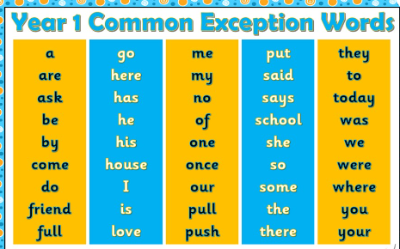

There is no one way to learn to spell words. Below are some strategies that you can use.
Fun ways to learn spellings at home


