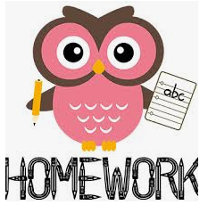
Year 1 homework
Summer Term 2
We are giving the children in Year 1 the opportunity to choose their own homework. They will need to complete 1 writing, 1 maths and 2 theme activities. These can be presented as creatively as possible through writing, drawings, pictures, displays, models, or anything else creative that your child thinks of. If you have any questions regarding your child’s homework, please speak to your child’s class teacher. We recommend that you help your child to spread the homework out over the half term ready to be brought into school on Thursday 9^{h} July 2026. The children will then be given the opportunity to share their homework with their peers.
Reading | Writing | Maths | Theme
Please read with your child as much as possible. Try to read different genres including fiction, non-fiction, poetry, scripts, and comics.  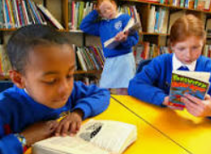    This half term we are learning about what the seaside was like 100 years ago.  Why not continue to explore an atlas, as you have done in class already?  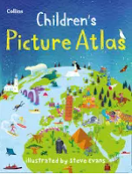 | Can you write an acrostic poem about the summer?  Sizzling on the beach,  Under umbrellas,  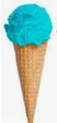  Making sandcastles,  My face is hot,  Eating ice-cream,  Relaxing in the sun. | Ask someone to mark the length of your shadow at two different times of the day. Can you measure the length of the shadows in cms.  Compare the measurements. Which is longer? Which is shorter? | 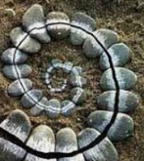  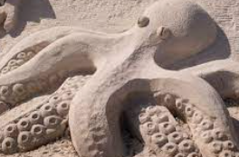  On a walk or day out create a piece of art from natural resources. Try to create the art in the location. Take a photo for your homework book.
 | Make a sun safety poster. Use time conjunctions.  First….  Next….  After that…  Then….    Lastly…... | Create a map on a grid of different objects or landmarks.  Write directions for how to move to one place to another. Use language such as half turn, full turn, quarter turn, left, right, steps forward/backwards etc. | 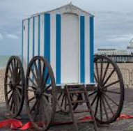  Can you make a model of a bathing machine from 100 years ago? It is like a beach hut but had wheels and could be wheeled into the water.
 | 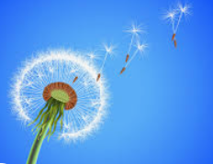  A dandelion seed can travel over 60 miles.  Write a short story about where a seed travels. What does it fly over? What happens to it? Where does it end up? | Do you have a money box or ‘piggy bank’.  Do you know what the different coins are worth?  Investigate different ways of making 5p and 10p.  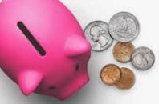  Record the ways in your homework book. | 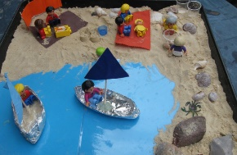  Make a 3D scene of the seaside. It could be a modern seaside or one from 100 years ago.  

