
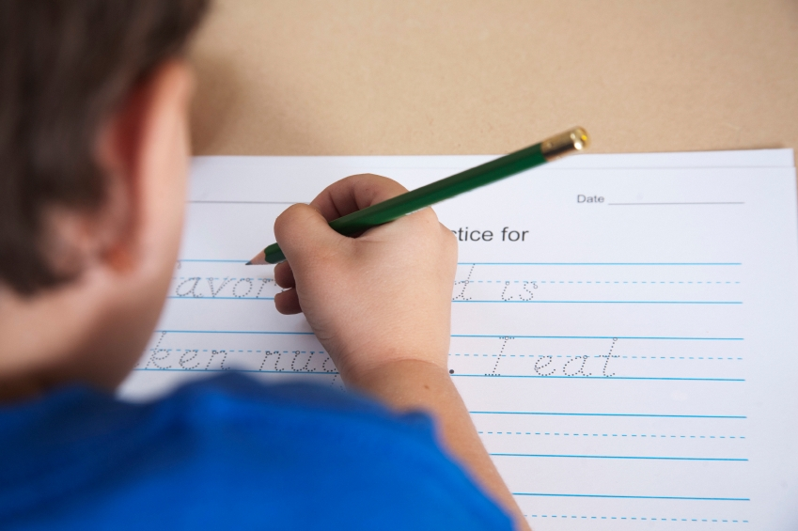

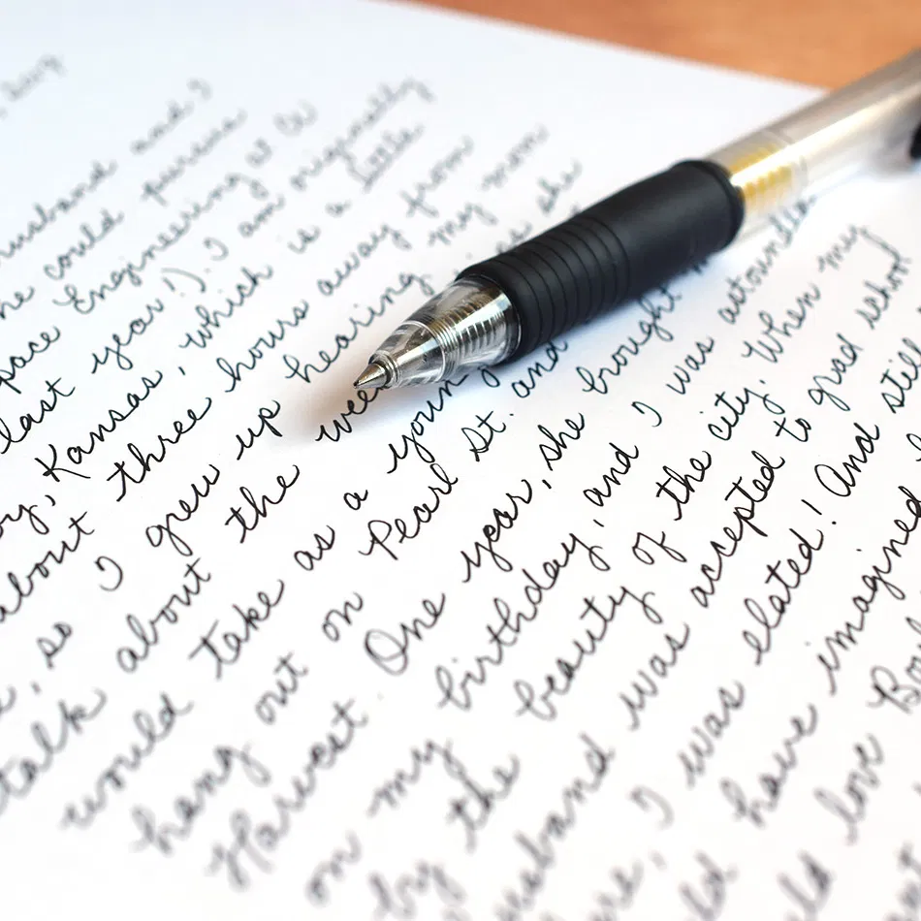

Progression Document
Handwriting
Nursery | Reception | Year 1
EYFS statutory framework requirements | EYFS statutory framework requirements | National Curriculum statutory requirements
 | Early Learning Goals  Physical Development- Fine Motor Skills  Hold a pencil effectively in preparation for fluent writing-using the tripod grip in almost all cases.  Literacy- Writing  Write recognisable letters, most of which are correctly formed. | - To write lower case and capital letters in the correct direction, starting and finishing in the right place with a good level of consistency.  - To sit correctly at a table, holding a pencil comfortable and correctly.  - To form capital letters.  - To form digits 0-9.  - To understand which letters belong to which handwriting ‘families’ (i.e letters that are formed in similar ways) and to practise these.
Penpals progression overview | Penpals progression overview | Penpals progression overview
Children will be focusing on developing the necessary fine and gross motor skills in readiness for handwriting. | Children will be focusing on developing the necessary fine and gross motor skills in readiness for handwriting. Initially, children practise a range of patterns including dots, waves and zig zags and then progress to practice forming individual letters. | In Year One, correct letter formation should become an automatic habit. Children should not be encouraged to write too small or too quickly. At the end of the year, children will begin to join some pairs of letters within words.
Sequence of teaching by term | Sequence of teaching by term | Sequence of teaching by term
Fine and gross motor development opportunities are planned for throughout the year and interwoven within the curriculum. Provocations and enhancements within continuous provision, as well as more structured activities such as ‘dough disco’ and ‘write dance’ develop children’s vital fine and gross motor control ready for writing. Penpals Interactive (Foundation 1) is used to support teaching and the ‘alphabet’ part of the programme is used to support children’s understanding of how letters are formed, linked to phonics learning. | Fine and gross motor development opportunities are planned for throughout the year and interwoven within the curriculum. Provocations and enhancements within continuous provision develop children’s vital fine and gross motor control ready for writing. Children use Penpals workbooks to support their handwriting practise.  Term 1  1 Dots  2 Straight lines and crosses  3 Circles  4 Waves  5 Loops and bridges  6 Joined straight lines  7 Angled patterns  8 Eights  9 Spirals  10 Left-to-right orientation  11 Mix of patterns  12 Review of patterns  Term 2  13 Introducing long-legged giraffe letters: l  14 Practising long-legged giraffe letters: l, i  15 Practising long-legged giraffe letters: u, t  16 Practising long-legged giraffe letters: j, y  17 Practising all the long-legged giraffe letters: l, i, t, u, j, y  18 Introducing one-armed robot letters: r  19 Practising one-armed robot letters: b, n  20 Practising one-armed robot letters: h, m  21 Practising one-armed robot letters: k, p  22 Practising all the one-armed robot letters: r, b, n, h, m, k, p  23 Practising all the long-legged giraffe and one-armed robot letters  24 Reviewing all the long-legged giraffe and one-armed robot letters  Term 3  25 Introducing curly caterpillar letters: c  26 Practising curly caterpillar letters: a, d  27 Practising curly caterpillar letters: o, s  28 Practising curly caterpillar letters: g, q  29 Practising curly caterpillar letters: e, f  30 Practising all the curly caterpillar letters: c, a, d, o, s, g, q, e, f  31 Practising all the curly caterpillar, long-legged giraffe and one-armed robot letters  32 Introducing zig-zag monster letters: z  33 Practising zig-zag monster letters: v, w, x  34 Practising all the zig-zag monster letters: z, v, w, x  35 Practising all the curly caterpillar and zig-zag monster letters  36 Reviewing all the curly caterpillar and zig-zag monster letters | Following Penpals (currently trialling Bug Club in line with phonics teaching. To be reviewed and updated, if necessary, in September 26):  Term 1  1 Practising long-legged giraffe letters  2 Writing words with ll  3 Introducing capitals for long-legged giraffe letters  4 Practising one-armed robot letters  5 Practising long-legged giraffe letters and one-armed robot letters  6 Introducing capitals for one-armed robot letters  7 Practising curly caterpillar letters  8 Writing words with double ff  9 Writing words with double ss  10 Introducing capitals for curly caterpillar letters  Term 2  11 Practising long-legged giraffe letters, one-armed robot letters and curly caterpillar letters  12 Practising zig-zag monster letters  13 Writing words with double zz  14 Mixing all the letter families  15 Practising all the capital letters  16 Practising all the numbers 0–9  17 Writing words with ck and qu  18 Practising long vowel phonemes: ai, igh, oo  19 Practising vowels with adjacent consonants: ee, oa, oo  20 End-of-term check  Term 3  21 Numbers 10–20: spacing  22 Practising ch unjoined  23 Introducing diagonal join to ascender: ch  24 Practising ai unjoined  25 Introducing diagonal join, no ascender: ai  26 Practising wh unjoined  27 Introducing horizontal join to ascender: wh  28 Practising ow unjoined  29 Introducing horizontal join, no ascender: ow  30 Assessment

Year 2 | Year 3 | Year 4
National Curriculum statutory requirements | National Curriculum statutory requirements | National Curriculum statutory requirements
- To form lower-case letters of the correct size relative to one another.  - To start using some of the diagonal and horizontal strokes needed to join letters and understand which letters, when adjacent to one another, are best left un-joined.  - To write capital letters and digits of the correct size, orientation and relationship to one another and to lower case letters.  - To use spacing between words that reflects the size of the letters. | - To use the diagonal and horizontal strokes that are needed to join letters and understand which letters, when adjacent to one another, are best left un-joined.  - To increase the legibility, consistency and quality of their handwriting (for example, by ensuring that the downstrokes of letters are parallel and equidistant; that lines of writing are spaced sufficiently so that the ascenders and descenders of letters do not touch). (Years 3 & 4) | - To use the diagonal and horizontal strokes that are needed to join letters and understand which letters, when adjacent to one another, are best left un-joined.  - To increase the legibility, consistency and quality of their handwriting (for example, by ensuring that the downstrokes of letters are parallel and equidistant; that lines of writing are spaced sufficiently so that the ascenders and descenders of letters do not touch). (Years 3 & 4)
Penpals progression overview | Penpals progression overview | Penpals progression overview
In Year Two, children will learn all of the basic handwriting joins. However, if they aren’t confident forming their letters yet, they should concentrate on this first before joining. Children will gradually be introduced to more pairs of letters that are joined in the same way.  At first, children are only asked to copy joins they have seen before but then gradually they explore and experiment joining more and more letters with the joins they know. | During Years Three and Four, children will be introduced to the idea of joining most of the letters in a word and to trickier joins such as joining from r, s and f.  As the movement for joins becomes more familiar and fluent, the focus moves to develop a neat and even style by looking at size and proportion, parallel downwards strokes and spacing. | During Years Three and Four, children will be introduced to the idea of joining most of the letters in a word and to trickier joins such as joining from r, s and f.  As the movement for joins becomes more familiar and fluent, the focus moves to develop a neat and even style by looking at size and proportion, parallel downwards strokes and spacing.
Sequence of teaching by term | Sequence of teaching by term | Sequence of teaching by term
Following Penpals (currently trialling Bug Club in line with phonics teaching. To be reviewed and updated, if necessary, in September 26):  Term 1  1 Practising diagonal join to ascender: th, ch  2 Practising diagonal join, no ascender: ai, ay  3 Practising diagonal join, no ascender: ir, er  4 Practising horizontal join to ascender: wh, oh  5 Practising horizontal join, no ascender: ow, ou  6 Introducing diagonal join to e: ie, ue  7 Introducing horizontal join to e: oe, ve  8 Introducing ee  9 Practising diagonal join, no ascender: le  10 Writing numbers 1–100  Term 2  11 Introducing diagonal join to anticlockwise letters: ea  12 Practising diagonal join to anticlockwise letters: igh  13 Practising diagonal join to anticlockwise letters: dg, ng  14 Introducing horizontal join to anticlockwise letters: oo, oa  15 Practising horizontal join to anticlockwise letters: wa, wo  16 16 Introducing mixed joins for three letters: air, ear  17 Practising mixed joins for three letters: oor, our  18 Practising mixed joins for three letters: ing  19 Size and spacing  20 End of term check  Term 3  21 Building on diagonal join to ascender: ck, al, el, at, il, ill  22 Building on diagonal join, no ascender: ui, ey, aw, ur, an, ip  23 Building on horizontal join to ascender: ok, ot, ob, ol  24 Building on horizontal join, no ascender: oi, oy, on, op, ov  25 Building on diagonal join to anticlockwise letters: ed, cc, eg, ic, ad, ug, dd, ag  26 Building on horizontal join to anticlockwise letters: oc, og, od, va, vo  27 Introducing joins to s: as, es, is, os, ws, ns, ds, ls, ts, ks  28 Practising joining ed and ing  29 Assessment  30 Capitals | Following Penpals:  Term 1  1 Practising joining through a word in stages: no ascenders or descenders  2 Practising joining through a word in stages: parallel ascenders  Introducing joining from s to ascender: sh, sl, st, sk  4 Introducing joining from s, no ascender: sw, si, se, sm, sn, sp, su  5 Introducing joining from s to an anticlockwise letter: sa, sc, sd, sg, so, sq  6 Introducing joining from r to an ascender: rb, rh, rk, rl, rt  7 Introducing joining from r, no ascender: ri, ru, rn, rp  8 Introducing joining from r to an anticlockwise letter: ra, rd, rg, ro  9 Introducing joining from r to e: are, ere, ure, ore, ire  10 Introducing break letters: g,j,y,,f,b,p,x,z  Term 2  11 Introducing joining to f: if, ef, af, of  12 Introducing joining from f to an ascender: fl, ft  13 Introducing joining from f, no ascender: fe, fi, fu, fr, fy  14 Introducing joining from f to an anticlockwise letter: fo, fa  15 Introducing ff joined  16 Introducing rr joined  17 Introducing ss joined  18 Introducing qu joined  19 Revising parallel ascenders and descenders  20 End-of-term check  Term 3  21 Revising joins: letter spacing  22 Revising joins: spacing between words  23 Revising joins: consistency of size  24 Revising joins: fluency  25 Revising joins: parallel ascenders  26 Revising joins: parallel ascenders and descenders  27 Revising horizontal join from r to an anticlockwise letter: rs  28 Revising break letters  29 Assessment  30 Revising capital letters | Following Penpals:  Term 1  1 Introducing diagonal join from p and b to ascender: ph, pl, bl  2 Introducing diagonal join from p and b, no ascender: bu, bi, be, pu, pi, pe  3 Introducing diagonal join from p and b to an anticlockwise letter: pa, po, ps, ba, bo, bs  4 Revising parallel ascenders and descenders: bb, pp  5 Break letters: x, z  6 Spacing in common exception words  7 Consistent size of letters  8 Relative size of capitals  9 Speed and fluency  10 End-of-term check  Term 2  11 Revising parallel ascenders  12 Revising parallel ascenders and break letters  13 Relative sizes of letters  14 Proportion of letters  15 Spacing between letters  16 Spacing between words  17 Writing at speed  18 Improving fluency  19 Speed and fluency  20 End-of-term check  Term 3  21 Consistency of size  22 Proportion  23 Spacing between letters and words  24 Size, proportion and spacing  25 Fluency: writing longer words  26 Speed and fluency  27 Revising break letters  28 Print alphabet: presentation  29 Assessment  30 Capital letters: presentation

Year 5 | Year 6
National Curriculum statutory requirements | National Curriculum statutory requirements
To write legibly, fluently and with increasing speed by:  - choosing which shape of a letter to use when given choices and deciding whether or not to join specific letters.  - choosing the writing implement that is best suited for a task. | To write legibly, fluently and with increasing speed by:  - choosing which shape of a letter to use when given choices and deciding whether or not to join specific letters.  - choosing the writing implement that is best suited for a task.
Penpals progression overview | Penpals progression overview
In Year Five, children are working on a more sloped style to enable speedier writing. All of the letters and joins taught previously will be revisited to enable children to practise the slope in familiar contexts. We will also focus on issues of proportion, size, legibility, and different styles for different purposes. | The emphasis this year is on developing a personal, fast, fluent and legible handwriting style. Children are given opportunities to practise a range of ways of joining, with the expectation that they will develop a style that ‘works’ for them. Additionally, children continue to focus on key issues for legibility and speed as well as styles and writing tools for different purposes.
Sequence of teaching by term | Sequence of teaching by term
Following Penpals:  Term 1  1 Introducing sloped writing in letter families  2 Practising sloped writing: diagonal join to ascender: th, sh, nb, nd, ht, st  3 Practising sloped writing: diagonal join, no ascender: ai, ay, kn, er, ie, en  4 Practising sloped writing: diagonal join to an anticlockwise letter: ac, sc, bo, da, ea, ho.  5 Practising sloped writing: horizontal join to ascender: wh, wl, oh, ol, of, ob  6 Practising sloped writing: horizontal join, no ascender: oi, oy, ou, op, ve  7 Practising sloped writing: horizontal join to an anticlockwise letter: oo, oa, wa, wo, va, vo  8 Practising sloped writing: joining from r: ra, re, ri, ro, ru  9 Practising sloped writing: joining from s: sh, su, sc, sl, sw, sp  10 End-of-term check  Term 2  11 Practising sloped writing: proportion – joining from f to ascender: fl, ft  12 Practising sloped writing: size – joining from f, no ascender: fa, fe, fi, fo, fu  13 Different styles for different purposes: writing a paragraph  14 Practising sloped writing: speed: ff  15 Practising sloped writing: speed and legibility: rr  16 Practising sloped writing: size, proportion and spacing: ss  17 Practising sloped writing: building speed: qu  18 Different styles for different purposes: decorative alphabets  19 Different styles for different purposes  20 End-of-term check  Term 3  21 Sloped writing: proportion, joining p and b to ascenders: ph, pl, bl  22 Handwriting for different purposes: joining from p and b, no ascender: bu, bi, pe, pu, pi, pr  23 Practising sloped writing: parallel downstrokes: pp, bb  24 Practising sloped writing: all double letters  25 Practising sloped writing for speed: tial, cial  26 Practising sloped writing for fluency  27 Personal style  28 Handwriting for different purposes: print alphabet  29 Assessment  30 Capitals | Following Penpals:  Term 1  1 Style for speed: crossbar join from t: th, ti, tr, ta, tt  2 Style for speed: looping from g: gl, gi, gr, ga, gg  3 Style for speed: looping from j and y: je, jo, ye, yr, yo  4 Style for speed: looping from f  5 Style for speed: different joins to s  6 Style for speed: looping from b  7 Style for speed: joining from v, w, x and z  8 Handwriting for different purposes: abbreviations  9 Spacing between words  10 End-of-term check  Term 2  11 Improving handwriting: the importance of consistent sizing  12 Improving handwriting: the importance of proportion  13 Improving handwriting: the importance of spacing  14 Improving handwriting: the importance of consistent sizing of parallel ascenders and descenders  15 Improving handwriting: the importance of closed and open letters  16 Improving handwriting: pen breaks in longer words  17 Handwriting for different purposes: annotations  18 Handwriting for different purposes  19 Choice of handwriting tools  20 End-of-term check  Term 3  21 Handwriting for different purposes: fast-joined and print letters  22 Handwriting for different purposes: note making  23 Handwriting for different purposes: neat writing  24 Handwriting for different purposes: print letters for personal details  25 Different styles of writing  26 Handwriting for different purposes: presentation  27 Handwriting for different purposes: decorated capitals  28 Handwriting for different purposes: layout  29 Assessment  30 Handwriting for different purposes: handwriting patterns

