Year 3 – Summer 1 Homework
For homework this half term, we would like children to choose one activity a week - please date and sign the activity when your child has completed it. Any learning that is written down should be recorded in their blue homework book (photos can also be stuck in here) and handed in on Thursday 21st April.
All homework should be completed using a sharp pencil. Please encourage your child to present their learning neatly and to use joined handwriting. Children must focus on spelling key words correctly and ensuring they use capital letters and full stops accurately. Their homework should be completed to the same standard as their learning in class.
History/Computing    During our computing lessons, we will be learning to use word. Use your computing learning to create a fact file about Roman Colchester. | French    In French, we are learning to say family members. Either draw or cut out photographs of your family members and underneath each person, write what their relationship is to you in French.
English    Using a thesaurus (you may use one online), look up more exciting words that mean the same as – kind, said, sad, happy, fun, pretty, big and small. | PE    Set yourself a fitness challenge. Record your score over the week and see if you improve. For example, how many times can you keep up a tennis ball, how fast can you run the length of your garden or how many star jumps can you do in a minute?
Science    Complete an investigation of your choice. You can use the link to help you find one. Think about how you will record your results. https://www.goodhousekeeping.com/life/parenting/g32176446/science-experiments-for-kids/ | Reading - Book review    Complete a book review about a book of your choice. This could be a book from home, your library book or your school reading book. Record what the book was about, whether you would recommend it and what you liked/disliked about it.
Money  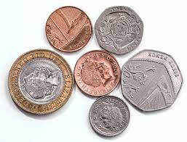  We would like you to visit the shops and to pay for any items you buy using coins/notes.  Can you select the correct money to use? Can you calculate how much change you will need? Record: what you bought, the cost of your items, the money you used and how much change you were given. | Capacity  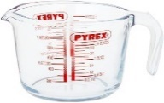  Last term, we learnt to measure capacity. We would like you to practise measuring liquids using different measuring jugs in ml and l – you must remember to look carefully at the intervals. Challenge yourself by either adding liquid together or pouring out and subtracting liquid. You could take some photos to show your learning.

