Year 4 Homework
Set Tuesday 3rd February– Due Monday 23rd February

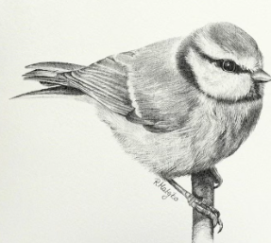
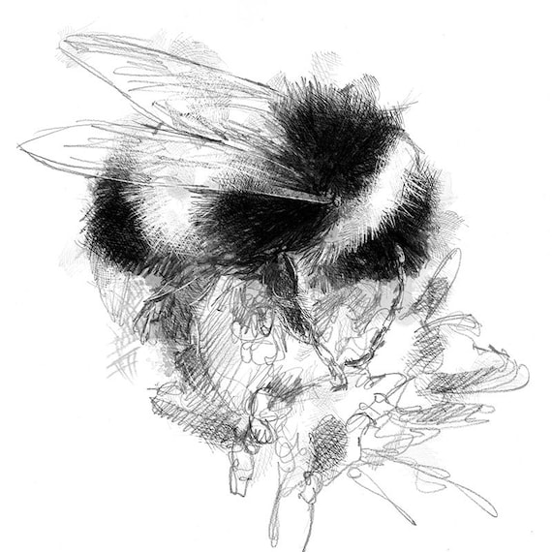
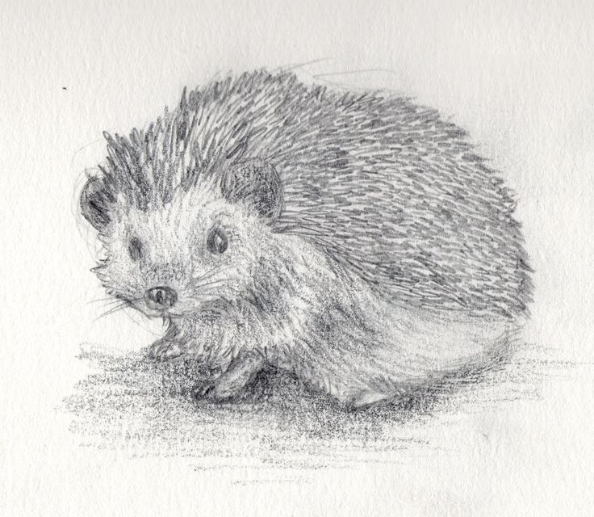

Experience

Take a walk in your local area with your family or an adult.

- Can you spot any creatures?
- Which trees/plants can you see?
- Which habitats can you see?
- Think about your learning on food chains, can you spot animals looking for food?

Task

Create a short piece of writing describing your walk. You could include (but are not limited to):

- Where you went.
- What the weather was like.
- Which type of place you went to.
- What you saw.
- How you felt about the experience.

