Year 4 Homework
Set Tuesday 20th January – Due Monday 2nd February

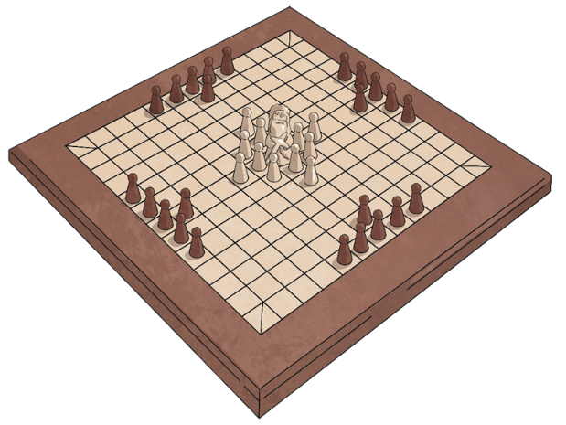
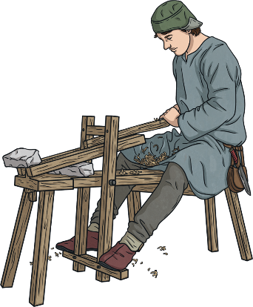

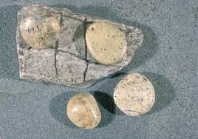
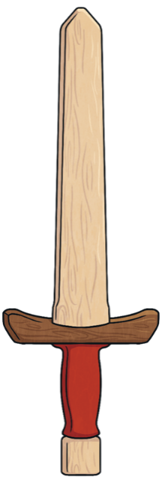
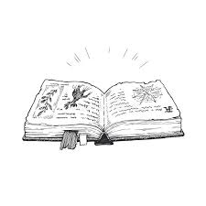

The Vikings were not just fierce warriors and hardworking farmers; they also enjoyed a variety of hobbies to relax and have fun. These activities were an important part of their daily lives, helping them bond with family and friends and pass on traditions to their children.
Research Vikings hobbies and create a fact file or poster about the one you find most interesting.

